EXTRACTION AND ANALYSIS OF DESIGN CONDITION DATA FROM THE REVISED ACDB
Eric Laurentius Peterson, PhD, RPEQ, Adjunct Senior Fellow, The University of Queensland

The present work aims to improve existing HVAC standards by exploiting the annals of NIWA’s revision of the Australian Climate Data Bank (ACDB) that documents climate variability at 80 locations 1967 - 2012. In contrast, 20th-century design conditions are listed in Table 1 of Commonwealth/AIRAH air-conditioning handbook DA09. The current project will offer an updated tabulation of design condition to allow HVAC designs in 80 locations around Australia, and establishes a methodology that could be extended to hundreds of other sites.
Implications for current industry practice
The present opportunity is to exploit the ACDB to update Table 1 of DA9 published 1973 & 1988 by the Australian Government Department of Housing and Construction, and revised by AIRAH 1998.
In the latest edition, DA9 Table 1 included 60 hourly stations in Australia from which HVAC system loads can be estimated to suit “critical conditions” (exceeded only 0.25% of hours), while synthetic data was offered in Appendix Table 1B to cover 600 locations based on 3PM observations. DA9 Table 1 “critical design” conditions were based on 10 years of hourly observations, excluding meteorological data subsequent to the Australian Bicentennial (1988). Practitioners are well aware DA9 is out-of date as urban heat islands have been evolving, and so there has been a tendency to apply oversizing margins. Most are not informed of the synthetic nature of DA9, it being a southern-hemisphere adaptation of the Carrier Air-conditioning method to estimate loads (CAMEL). Meanwhile the American Society of Heating, Refrigeration, and Air-conditioning Engineers (ASHRAE) 2009 Handbook recommends designing on the basis of real hourly data sets with coincident dry- and wet-bulb temperatures. ASHRAE offers design conditions which are not expected to be exceeded 2%, 1%, and 0.4% of the time, leaving it to the designer to decide which confidence level is desired.
ASHRAE offers for sale a DVD of their recommended design conditions for the world (2009), but this information is not available publically. Meanwhile the Australian industry is trapped in a process of using compounding “safety margin” assumptions without access to current Australian climatic data. New software tools are allowing for sophisticated load estimation, but depend on 24 hour design-day data rather than the assumed 3PM maxima stated in DA9. Coastal Australian temperatures peak shortly after noon and this should be accounted for in building design rather than the focus on 3PM.
Confidence in revised climate data should reduce oversize margins and HVAC system efficiency – so this work could be delivered at the 2013 AIRAH National Conference on the Future of HVAC.
Action plan
The present project is planned as a “bridge” between historical and future approaches that provides up-to-date data in a variety of formats. The data will be made available freely and can be incorporated into design processes as people see fit, allowing a continuation of old methods or incorporation of your newer, more accurate and realistic approach. The first step is to revise DA9 Table 1 and to create three design-day files to suit the program CAMEL, one for dry summers, one for wet summers, and one for moderately critical conditions.
This will increase the temporal coverage of HVAC design data by exploiting the ACDB, it being a set of 80 high quality annals of hourly meteorological data that generally span 45 years (1967-2012). This will provide HVAC designers with design data detailing current climate at 80 key locations, and track local changes in the past 45 years in order to inform likely conditions mid-century (2050). In the future, the methods developed can be applied to increase spatial coverage to 600 locations by working with the Bureau of Meteorology to process automatic weather station data.
DA9 includes 14 hourly stations that are not covered by the ACDB because they were closed manual stations. Consequently we will analyse Bureau of Meteorology automatic weather station data near those older manned stations to complete revision of Table 1 at these locations as well as a few case studies of urban heat island effects in capital city central business districts: Brisbane (RO) since 1999, Sydney (Observation Hill) since 1993, Melbourne (RO) since 1997, Adelaide (Kent Town) since 1993, Hobart (Ellerslie Road) since 1994, and Perth (Metro) since 1993.
As an additional quality control, consideration is also given to approximate design temperatures extracted from Queensland Government’s patched point dataset (PPD) at the 80 locations. Figure 1 presents the example of Tullamarine where dynamic dry-bulb design temperature is modelled as the linear regression of the 10th highest maximum per annum plus the standard estimate of the error STEYX. In this example just over half of the inter-annual variability of the tenth-hottest temperature is fitted by the linear regression with a warming trend of 2.6 °C per century.
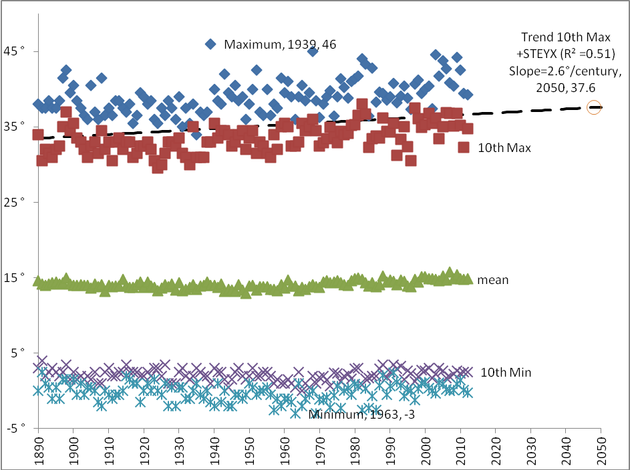
Figure 1: PPD analysis for Tullamarine projecting 2050 dry bulb design temperature of 37.6°.
Given the PPD availability at thousands of locations around Australia, this provides a preliminary evaluation of local climate influences such as urbanization and distance from coastlines. It should be stated that PPD are annals of daily rainfall, solar radiation, humidity, and minimum and maximum daily temperatures since the 19th century rather than 8AM and 3PM observations that are the basis of DA9.

Key gains from the present research:
• DA9 includes 46 hourly stations that are covered by the ACDB (validation).
• ACDB adds the most recent 25 years since the Australian Bicentennial (climate change).
• The ACDB adds 34 hourly stations to the set established by DA9 (greater spatial span).
• The ACDB provides coincident solar radiation data as well as wet and dry bulb values.

METHODOLOGY
The processing of ACDB datasets was developed in MatLab computer script that could be given to the Bureau of Meteorology for integration into their ongoing analysis of automatic weather stations.
An example of outputs for processing of ACDB data into Table 1 format is provided as a case study of Tullamarine Airport (Melbourne). We based the analysis on the ten years DA9 data 1974-1984 as used in the current Table 1 for validation:
______________________________________________________________________________________________________
| LOCATION |Option 1 Dry summer | Option 2 Wet summer | 24 hour | 8AM-6PM |
| |design DB / coinc WB | coinc DB / design WB | DB / WB | DB / WB |
|Tullamarine (Melbourne Airport) TU | 36.0 DDB / 18.4 CWB | 29.4 CDB / 20.4 DWB |37.0/20.4|38.0/20.8|
|CZ 60 post 3020 BoM 86282 WMO 94866| | | ¼ % | ¼ % |
|___________________________________|_____________________|______________________|_________|_________|
_____________________________________________________________________________
|Winter(8AM)|24 hour|8AM-6PM| Elev | Lat | Long | Daily | Yearly | Data |
| comfort |criticl|criticl| (m) | (°) | (°) | Range | Range | Years |
| 2.0 °C | 2.0 °C| 3.0 °C| 118.8|-37.67|144.83|13.0 °C| 34.0 °C|1975-1984|
| | ¼ % | ¼ % | | | | | | |
|___________|_______|_______|______|______|______|_______|________|_________|

For the entire dataset for Tullamarine Airport (45 years from 1967-2012) results are as follows:
______________________________________________________________________________________________________
| LOCATION |Option 1 Dry summer | Option 2 Wet summer | 24 hour | 8AM-6PM |
| |design DB / coinc WB | coinc DB / design WB | DB / WB | DB / WB |
|Tullamarine (Melbourne Airport) TU | 35.4 DDB / 17.8 CWB | 27.6 CDB / 20.4 DWB |36.0/20.5|38.0/20.9|
|CZ 60 post 3020 BoM 86282 WMO 94866| | | ¼ % | ¼ % |
|___________________________________|_____________________|______________________|_________|_________|
_____________________________________________________________________________
|Winter(8AM)|24 hour|8AM-6PM| Elev | Lat | Long | Daily | Yearly | Data |
| comfort |criticl|criticl| (m) | (°) | (°) | Range | Range | Years |
| 2.9 °C | 2.0 °C| 3.6 °C| 118.8|-37.67|144.83|12.5 °C| 32.5 °C|1967-2011|
| | ¼ % | ¼ % | | | | | | |
|___________|_______|_______|______|______|______|_______|________|_________|

The apparent decrease in design conditions of the whole 45-year dataset could be related to the increase of precision with the commissioning of automatic weather station at in the 1990’s.

Output of data suitable for a range of applications (CAMEL and EnergyPlus)
Additional to the tabulation of DA9 Table 1, the appendix tabulates three sets of 12 monthly 24 hour design days suitable for the computer program CAMEL. These factors can be readily converted into EnergyPlus format. For the present opportunity the CAMEL files are currently being tested on the same building specification at each capital city airport.
Appendix includes three design-day tables for Tullamarine Airport:
- TU_60_DB -intended to represent DA9 “Option 1” Dry summers selected for DB.
- TU_60_WB -intended to represent DA9 “Option 2” Wet summers selected for WB.
- TU_60_CR -intended to represent DA9 “Design Values” selected for DB and WB.
“TU_60_CR” is similar to the assumptions that program CAMEL uses to estimate loads. The present opportunity will explore the differences that result from using the other two weather files as alternatives “Option 1” and “Option 2”. The present author’s experience is that loads are substantially over estimated using the “Design Values”, and so it appears that this combination of effects should be considered “Critical Conditions”. This assertion is supported by the finding that 0.56% of the coincident dry- and wet-bulb hourly data was above the design dry-bulb or the design wet-bulb. That is to say that what DA9 described as “Design Values” is exceeded only 0.56% of the time - near ASHRAE’s stringent design confidence percentile 0.4% - while “Option 1” and “Option 2” coincident conditions are worse than ASHRAE’s 2% design.
Table 2: Hours exceeding design temperatures at Tullamarine 1967-2012
______________________________________________
|Option 1 Dry summer | Option 2 Wet summer |
|design DB / coinc WB | coinc DB / design WB |
| 35.4 DDB / 17.8 CWB | 27.6 CDB / 20.4 DWB |
|_____________________|______________________|
|percentage of hourly data exceeding levels |
|design DB | coinc WB | coinc DB | design WB |
| 0.31 % | 2.59 % | 3.15 % | 0.27 % |
|__________|__________|__________|___________|
|design DB & coinc WB | coinc DB % design WB |
| 2.71 % | 3.28 % |
|_____________________|______________________|
| design DB concurrent with design WB |
| 0.56 % |
|____________________________________________|

To illustrate the combined impact of the design WB concurrent with design DB consider the following two plots of the 24 hour x 12 month table 3 TU_60_CR in the Appendix.
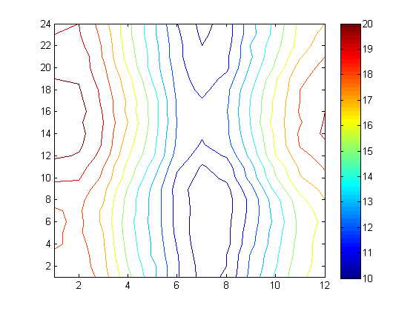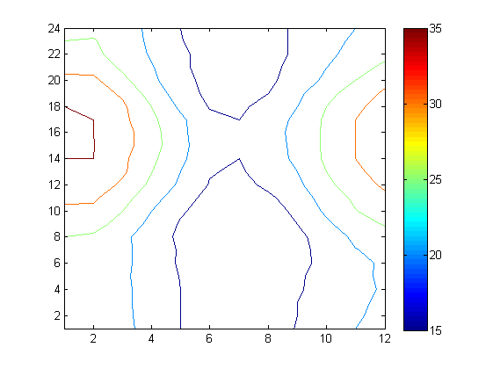
Figure 2: Tullamarine airport design wet-bulb(left) and design dry-bulb (right) 24 hr x 12 mo
Table 3 was generated by sorting the wet-bulb and dry-bulb data into bins (24 hours x 12 months). Record is made of the number exceeding the design DB and design WB within each bin, and from this the month of worst-case is determined (for example maximum 4PM January). So percentile thresholds are determined separately for WB and DB, and then these are applied over all bins to generate curves plotted above. For Option 1 and Option 2, mean coincident curves are generated. Other coincident curves can also determined for Option 1 or Option 2, such as solar radiation.
In the first instance 79 other locations will follow the example of design conditions for Tullamarine Airport, such that up-to date design conditions are made available to HVAC system designers. The present research is only proposed as an amendment to DA9, and so we seek feedback from industry.

Summary
· DA9 design conditions are out of date. We need to measure change of climate and urban heat islands. We need to give designers the confidence to neglect oversizing margins.
· Some Australian cities peak before 3pm and this should be accounted for in building design. Modern software tools and engines such as EnergyPlus provide sophisticated load estimation.
· The new data will be made available freely and can be incorporated into design processes as people see fit, allowing a continuation of old methods or incorporation of your newer, more accurate and realistic approach.
This is not an accepted revision of DA9, but a discussion document seeking industry consultation. Please email e.peterson@uq.edu.au directly with any issues you may have. I would be particularly interested in learning what tools, software, and methodology your organization uses to estimate air-conditioning loads. I also would like to understand your approach to load estimating at locations that are not near airports. How to you approach coastal and mountain site?

Appendix Table 3 (TU_60_DB, TU_60_WB, and TU_60_CR) appears in the follow three pages.
TU_60_DB 12.5 37.7S
6AM DB 23.0 23.5 21.0 18.0 14.3 12.0 11.0 11.7 14.0 16.1 19.0 20.6
WB 15.6 15.5 14.3 12.8 11.0 9.6 8.5 8.4 9.5 12.1 13.1 14.3
7AM DB 23.9 23.2 21.0 18.0 14.5 12.0 11.0 11.3 14.0 16.2 19.8 21.7
WB 15.7 15.8 14.1 12.5 11.3 9.7 8.6 8.4 9.6 11.8 13.5 14.2
8AM DB 25.0 24.1 21.0 17.7 14.0 11.7 11.0 11.0 14.0 17.0 21.2 23.5
WB 16.1 16.1 14.4 12.7 11.0 9.5 8.7 8.3 10.0 11.7 13.9 14.2
9AM DB 27.0 26.9 23.0 18.7 14.4 12.0 10.8 12.0 15.0 19.0 23.0 25.3
WB 16.6 16.1 15.2 12.6 11.3 9.9 8.2 8.6 10.4 12.4 14.8 15.1
10AM DB 29.0 29.0 25.0 20.0 15.7 12.0 11.0 13.0 16.0 20.9 24.8 27.8
WB 16.7 17.1 15.6 13.0 11.4 9.6 8.3 9.1 10.4 13.0 15.1 15.6
11AM DB 31.0 30.7 26.8 21.9 17.1 13.3 12.4 14.1 17.5 22.0 26.0 29.1
WB 16.9 17.5 16.2 13.4 11.9 9.9 8.7 9.3 11.3 13.6 15.4 15.9
NOON DB 33.0 33.0 29.0 24.0 19.0 14.7 13.4 16.0 19.0 24.0 27.5 30.9
WB 17.1 17.8 16.5 14.2 12.3 10.3 9.3 10.2 11.4 13.8 16.1 16.5
1PM DB 34.0 34.0 30.8 25.1 20.0 15.3 14.4 17.0 20.0 25.0 29.0 32.0
WB 17.9 17.9 16.9 14.4 12.7 10.4 9.4 10.5 11.8 14.5 16.5 16.2
2PM DB 35.0 35.0 31.0 26.0 21.0 16.0 15.0 17.6 21.0 26.0 30.0 33.0
WB 17.4 18.0 16.9 14.5 12.7 10.6 9.5 10.5 12.2 15.1 15.9 16.5
3PM DB 35.0 35.1 32.0 27.0 21.4 16.4 15.4 18.0 21.1 26.0 30.0 33.0
WB 17.6 17.8 17.1 14.7 12.8 10.8 9.7 10.6 12.5 15.0 16.3 16.6
4PM DB 35.5 35.0 32.0 27.0 21.1 16.3 15.3 18.0 21.5 26.0 30.1 33.0
WB 17.8 17.8 17.0 14.5 13.2 10.7 9.6 10.5 12.5 15.0 16.4 16.7
5PM DB 35.0 35.0 31.3 26.0 21.0 16.0 15.0 17.7 21.0 26.0 30.0 33.0
WB 18.0 17.9 16.8 14.3 12.6 10.5 9.7 10.5 12.6 14.7 16.2 16.3
6PM DB 35.0 34.3 31.0 25.0 19.0 14.7 14.0 17.0 20.0 25.0 29.0 32.0
WB 17.8 17.7 16.4 14.0 12.3 10.5 9.5 10.5 12.2 14.2 16.5 16.6
7PM DB 33.8 33.0 29.0 23.0 17.6 13.7 13.0 15.0 19.0 23.3 27.6 30.7
WB 17.2 17.0 16.6 13.8 12.5 10.2 9.5 10.0 12.2 14.2 16.4 16.1
8PM DB 31.6 31.0 26.2 21.0 17.0 13.0 12.3 14.0 17.4 21.0 25.0 29.0
WB 17.3 17.3 16.0 13.3 12.1 10.1 9.2 9.6 11.9 13.1 15.8 15.9
9PM DB 28.4 28.3 24.2 20.4 16.0 13.0 12.0 13.5 16.8 19.9 23.0 26.0
WB 17.0 17.0 15.6 13.1 11.7 10.2 9.0 9.5 11.4 12.6 15.1 15.6
10PM DB 26.1 26.0 23.0 19.4 16.0 12.9 12.0 13.0 16.0 18.8 22.0 24.0
WB 16.6 17.2 15.4 13.0 11.9 10.0 8.9 9.3 11.2 13.0 15.0 15.4
11PM DB 25.0 25.3 22.7 19.0 15.2 12.6 12.0 13.0 16.0 18.0 21.0 23.0
WB 17.4 17.0 15.0 13.0 11.7 9.9 8.9 9.0 11.2 12.7 14.5 15.2
MIDN DB 24.5 24.0 21.9 19.0 15.0 12.5 11.7 13.0 16.0 17.8 20.0 22.0
WB 16.3 16.2 15.4 12.9 11.5 9.9 8.7 9.0 11.7 12.3 14.5 15.5
1AM DB 24.0 24.0 21.2 18.4 15.0 12.6 11.5 12.5 15.3 17.0 20.0 21.0
WB 16.8 16.9 15.0 12.6 11.5 9.9 8.5 8.9 11.2 12.6 14.9 15.4
2AM DB 24.0 24.0 21.0 18.3 15.0 12.5 11.3 12.1 15.0 17.0 19.6 21.0
WB 16.3 16.3 14.9 12.7 11.4 9.8 8.5 9.0 10.5 12.3 14.1 15.1
3AM DB 23.9 23.8 21.0 18.0 15.0 12.3 11.0 12.0 15.0 17.0 19.4 20.7
WB 16.1 15.8 14.6 12.6 11.6 9.8 8.3 8.9 10.7 12.5 13.9 15.1
4AM DB 23.7 23.3 21.0 18.1 15.0 12.0 11.0 12.0 14.5 17.0 19.2 20.3
WB 15.9 15.3 14.5 12.3 11.7 9.4 8.3 8.7 10.2 12.4 14.0 14.4
5AM DB 23.3 23.5 20.8 18.0 14.8 12.0 11.0 12.0 14.3 16.8 19.1 20.6
WB 15.1 15.5 14.5 12.3 11.3 9.5 8.4 8.5 10.3 12.1 13.7 14.4

TU_60_WB 12.5 37.7S
6AM DB 20.9 20.9 18.9 16.4 14.2 12.0 10.5 11.2 13.7 15.3 17.7 19.5
WB 17.7 18.3 16.8 14.4 12.7 10.7 9.3 9.7 11.4 13.3 15.3 16.3
7AM DB 20.9 21.1 19.1 16.8 14.1 12.1 10.6 11.0 13.4 15.9 18.3 19.4
WB 17.9 18.2 16.8 14.6 12.7 10.7 9.4 9.6 11.3 13.5 15.4 16.5
8AM DB 22.3 21.6 19.1 16.7 14.0 11.9 10.4 11.0 13.4 16.3 19.6 21.0
WB 18.2 18.3 17.1 14.6 12.7 10.7 9.3 9.6 11.3 13.6 15.7 17.0
9AM DB 23.5 22.8 20.1 17.5 14.1 11.7 10.3 11.4 14.5 17.7 21.1 22.4
WB 18.5 18.7 17.3 14.9 12.8 10.6 9.2 9.7 11.7 14.3 16.3 17.3
10AM DB 25.8 25.0 21.5 18.5 14.7 12.1 10.8 12.3 16.1 19.2 22.4 25.0
WB 19.3 19.1 17.8 15.4 13.2 10.8 9.6 10.2 12.4 14.9 16.9 17.8
11AM DB 27.2 26.3 23.2 19.8 15.9 13.0 11.7 13.2 17.3 20.0 23.6 26.3
WB 19.5 19.5 18.0 15.7 13.6 11.2 9.9 10.4 12.7 15.2 17.2 18.1
NOON DB 29.2 28.8 25.7 21.5 17.4 13.8 12.7 14.7 18.6 22.0 25.4 28.0
WB 20.2 19.9 18.6 16.1 14.2 11.6 10.5 11.1 13.3 16.0 17.6 18.5
1PM DB 30.2 29.9 27.7 22.9 18.2 14.5 13.5 16.1 19.8 23.3 26.2 28.4
WB 20.2 20.2 18.9 16.4 14.4 11.8 10.9 11.6 13.6 16.2 18.1 18.8
2PM DB 31.2 30.6 28.6 23.7 19.2 15.0 14.3 16.9 20.1 23.9 27.2 29.3
WB 20.4 20.4 18.9 16.7 14.5 11.9 11.1 11.8 13.9 16.2 18.2 19.2
3PM DB 31.3 30.1 29.0 24.3 19.7 15.2 14.5 17.3 20.2 25.0 27.1 29.3
WB 20.3 20.2 19.0 17.0 14.6 12.0 11.1 11.8 14.1 16.5 17.9 19.1
4PM DB 31.4 29.8 28.6 24.1 19.3 15.1 14.5 17.5 20.5 24.1 27.4 29.0
WB 20.4 20.5 18.9 16.7 14.6 11.9 11.1 11.9 14.1 16.3 18.1 19.0
5PM DB 30.7 29.4 27.5 23.7 19.4 14.7 14.3 17.0 20.1 24.3 26.7 28.5
WB 20.2 20.3 18.8 16.8 14.6 11.9 11.1 11.8 14.1 16.3 18.0 18.9
6PM DB 29.3 28.3 26.8 22.3 17.7 13.8 13.3 16.1 19.5 23.2 25.7 28.0
WB 20.1 20.1 18.7 16.5 14.3 11.7 10.7 11.7 13.9 16.0 18.0 18.7
7PM DB 28.3 27.5 24.9 20.5 16.5 13.3 12.3 14.6 17.8 21.9 24.4 26.5
WB 20.0 19.9 18.4 16.4 13.9 11.6 10.4 11.3 13.5 15.9 17.8 18.5
8PM DB 27.0 26.1 22.8 19.5 15.8 13.1 11.7 13.5 17.0 20.0 23.2 24.8
WB 19.8 19.7 18.2 15.9 13.6 11.5 10.1 10.8 13.2 15.2 17.5 18.3
9PM DB 25.3 24.6 21.8 18.7 15.5 12.7 11.5 13.2 16.2 18.8 21.3 22.4
WB 19.6 19.8 17.9 15.6 13.6 11.3 10.0 10.8 12.9 14.9 16.9 18.0
10PM DB 23.5 23.5 20.8 18.0 15.1 12.7 11.5 12.6 16.2 17.9 20.3 20.7
WB 19.2 19.3 17.9 15.5 13.5 11.3 10.0 10.5 13.1 14.6 16.5 17.6
11PM DB 22.9 22.4 20.4 17.5 14.8 12.5 11.4 12.5 16.0 17.1 19.5 20.4
WB 19.0 19.1 17.7 15.3 13.3 11.2 9.8 10.5 12.6 14.4 16.4 17.3
MIDN DB 22.1 21.9 19.5 17.4 14.6 12.4 11.2 12.4 15.7 16.9 19.0 19.9
WB 18.8 19.0 17.5 15.3 13.3 11.0 9.7 10.4 12.7 14.3 16.3 17.0
1AM DB 21.7 21.7 19.2 17.1 14.7 12.6 11.2 11.9 15.3 16.8 18.1 18.9
WB 18.5 19.0 17.5 15.3 13.3 11.1 9.7 10.1 12.3 14.2 15.8 16.6
2AM DB 21.7 21.1 19.4 17.0 14.6 12.6 10.9 11.7 14.8 16.7 18.1 18.8
WB 18.3 18.7 17.3 15.0 13.3 11.1 9.6 10.0 12.2 13.9 15.7 16.4
3AM DB 21.0 21.1 19.0 17.2 14.3 12.7 10.7 11.7 14.4 16.5 18.1 18.8
WB 18.2 18.6 17.2 14.8 12.9 11.1 9.4 10.0 12.1 13.8 15.5 16.5
4AM DB 20.7 20.8 18.9 17.1 14.5 12.3 10.4 11.4 14.0 16.0 18.1 19.1
WB 17.8 18.4 17.1 14.6 12.9 10.9 9.3 9.7 11.7 13.6 15.5 16.5
5AM DB 20.8 20.5 18.7 16.2 14.3 12.1 10.5 11.3 13.8 15.7 18.0 19.1
WB 17.9 18.2 17.0 14.5 12.8 10.7 9.3 9.7 11.6 13.5 15.3 16.5

TU_60_CR 12.5 37.7S
6AM DB 23.0 23.5 21.0 18.0 14.3 12.0 11.0 11.7 14.0 16.1 19.0 20.6
WB 17.7 18.3 16.8 14.4 12.7 10.7 9.3 9.7 11.4 13.3 15.3 16.3
7AM DB 23.9 23.2 21.0 18.0 14.5 12.0 11.0 11.3 14.0 16.2 19.8 21.7
WB 17.9 18.2 16.8 14.6 12.7 10.7 9.4 9.6 11.3 13.5 15.4 16.5
8AM DB 25.0 24.1 21.0 17.7 14.0 11.7 11.0 11.0 14.0 17.0 21.2 23.5
WB 18.2 18.3 17.1 14.6 12.7 10.7 9.3 9.6 11.3 13.6 15.7 17.0
9AM DB 27.0 26.9 23.0 18.7 14.4 12.0 10.8 12.0 15.0 19.0 23.0 25.3
WB 18.5 18.7 17.3 14.9 12.8 10.6 9.2 9.7 11.7 14.3 16.3 17.3
10AM DB 29.0 29.0 25.0 20.0 15.7 12.0 11.0 13.0 16.0 20.9 24.8 27.8
WB 19.3 19.1 17.8 15.4 13.2 10.8 9.6 10.2 12.4 14.9 16.9 17.8
11AM DB 31.0 30.7 26.8 21.9 17.1 13.3 12.4 14.1 17.5 22.0 26.0 29.1
WB 19.5 19.5 18.0 15.7 13.6 11.2 9.9 10.4 12.7 15.2 17.2 18.1
NOON DB 33.0 33.0 29.0 24.0 19.0 14.7 13.4 16.0 19.0 24.0 27.5 30.9
WB 20.2 19.9 18.6 16.1 14.2 11.6 10.5 11.1 13.3 16.0 17.6 18.5
1PM DB 34.0 34.0 30.8 25.1 20.0 15.3 14.4 17.0 20.0 25.0 29.0 32.0
WB 20.2 20.2 18.9 16.4 14.4 11.8 10.9 11.6 13.6 16.2 18.1 18.8
2PM DB 35.0 35.0 31.0 26.0 21.0 16.0 15.0 17.6 21.0 26.0 30.0 33.0
WB 20.4 20.4 18.9 16.7 14.5 11.9 11.1 11.8 13.9 16.2 18.2 19.2
3PM DB 35.0 35.1 32.0 27.0 21.4 16.4 15.4 18.0 21.1 26.0 30.0 33.0
WB 20.3 20.2 19.0 17.0 14.6 12.0 11.1 11.8 14.1 16.5 17.9 19.1
4PM DB 35.5 35.0 32.0 27.0 21.1 16.3 15.3 18.0 21.5 26.0 30.1 33.0
WB 20.4 20.5 18.9 16.7 14.6 11.9 11.1 11.9 14.1 16.3 18.1 19.0
5PM DB 35.0 35.0 31.3 26.0 21.0 16.0 15.0 17.7 21.0 26.0 30.0 33.0
WB 20.2 20.3 18.8 16.8 14.6 11.9 11.1 11.8 14.1 16.3 18.0 18.9
6PM DB 35.0 34.3 31.0 25.0 19.0 14.7 14.0 17.0 20.0 25.0 29.0 32.0
WB 20.1 20.1 18.7 16.5 14.3 11.7 10.7 11.7 13.9 16.0 18.0 18.7
7PM DB 33.8 33.0 29.0 23.0 17.6 13.7 13.0 15.0 19.0 23.3 27.6 30.7
WB 20.0 19.9 18.4 16.4 13.9 11.6 10.4 11.3 13.5 15.9 17.8 18.5
8PM DB 31.6 31.0 26.2 21.0 17.0 13.0 12.3 14.0 17.4 21.0 25.0 29.0
WB 19.8 19.7 18.2 15.9 13.6 11.5 10.1 10.8 13.2 15.2 17.5 18.3
9PM DB 28.4 28.3 24.2 20.4 16.0 13.0 12.0 13.5 16.8 19.9 23.0 26.0
WB 19.6 19.8 17.9 15.6 13.6 11.3 10.0 10.8 12.9 14.9 16.9 18.0
10PM DB 26.1 26.0 23.0 19.4 16.0 12.9 12.0 13.0 16.0 18.8 22.0 24.0
WB 19.2 19.3 17.9 15.5 13.5 11.3 10.0 10.5 13.1 14.6 16.5 17.6
11PM DB 25.0 25.3 22.7 19.0 15.2 12.6 12.0 13.0 16.0 18.0 21.0 23.0
WB 19.0 19.1 17.7 15.3 13.3 11.2 9.8 10.5 12.6 14.4 16.4 17.3
MIDN DB 24.5 24.0 21.9 19.0 15.0 12.5 11.7 13.0 16.0 17.8 20.0 22.0
WB 18.8 19.0 17.5 15.3 13.3 11.0 9.7 10.4 12.7 14.3 16.3 17.0
1AM DB 24.0 24.0 21.2 18.4 15.0 12.6 11.5 12.5 15.3 17.0 20.0 21.0
WB 18.5 19.0 17.5 15.3 13.3 11.1 9.7 10.1 12.3 14.2 15.8 16.6
2AM DB 24.0 24.0 21.0 18.3 15.0 12.5 11.3 12.1 15.0 17.0 19.6 21.0
WB 18.3 18.7 17.3 15.0 13.3 11.1 9.6 10.0 12.2 13.9 15.7 16.4
3AM DB 23.9 23.8 21.0 18.0 15.0 12.3 11.0 12.0 15.0 17.0 19.4 20.7
WB 18.2 18.6 17.2 14.8 12.9 11.1 9.4 10.0 12.1 13.8 15.5 16.5
4AM DB 23.7 23.3 21.0 18.1 15.0 12.0 11.0 12.0 14.5 17.0 19.2 20.3
WB 17.8 18.4 17.1 14.6 12.9 10.9 9.3 9.7 11.7 13.6 15.5 16.5
5AM DB 23.3 23.5 20.8 18.0 14.8 12.0 11.0 12.0 14.3 16.8 19.1 20.6
WB 17.9 18.2 17.0 14.5 12.8 10.7 9.3 9.7 11.6 13.5 15.3 16.5

